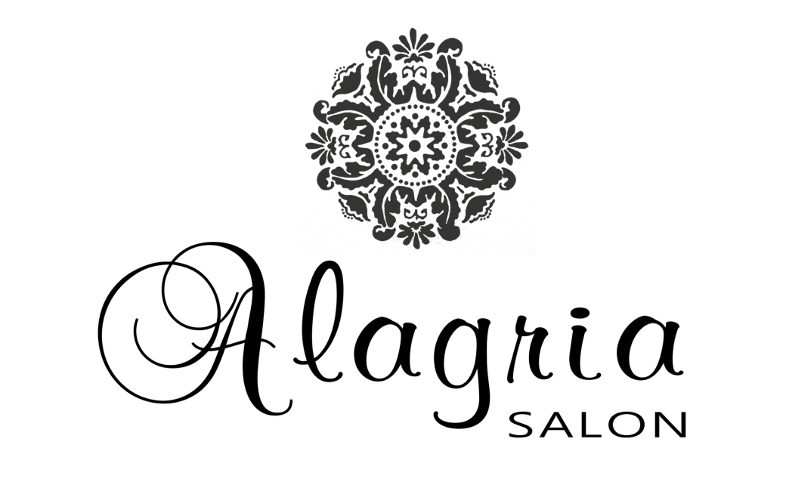

A little reminder for Special Occasion Hair
- Remember to wear a button down shirt to the salon that day
- Please be on time. If your wedding is a Saturday as are most, the salon has a full day of clients to service.
- Determine your time of appointment by talking to the stylist about the time you need to be walking out the door. Think about the Photographer’s schedule for extra time for makeup and getting dressed.
- Please bring all pre determined hair accessories to the salon with you that day.
- Let the stylist know if your veil or headpiece is coming off or staying on all day.
- For best results, unless otherwise discussed, please wash your hair the night before. It will stay much better and be less fly away if it is a little ‘dirty’. (shh its our secret).
- Unless otherwise noted, hair should be dry but not necessarily styled and without product unless specified.
- If you have others getting their hair done with you, please make sure they are on time; remind them about the shirt and clean (but not too clean) dry hair.
- If a consultation has not taken place, please bring pictures with you and be prepared to discuss with your stylist your goals and what you absolutely do not want. Remember, we are not mind readers, for great success , communication need to happen and be clear.
- Make sure to call the salon if there are any changes.
- Do not be afraid to accept suggestions, remember we do this often, and can make recommendations on workable styles for certain hairpieces, themes, or hair types.

Most of all, relax and have a great day or evening. We appreciate your business and we are honored to be part of your special day

